Show your engineering spirit with…
~AEDT T-SHIRTS by E-PA~
BY AND FOR THE GREATEST ACADEMY AT BCA!
All proceeds go to the support and funding of engineering activities, trips, and teams.
ONLY $15!
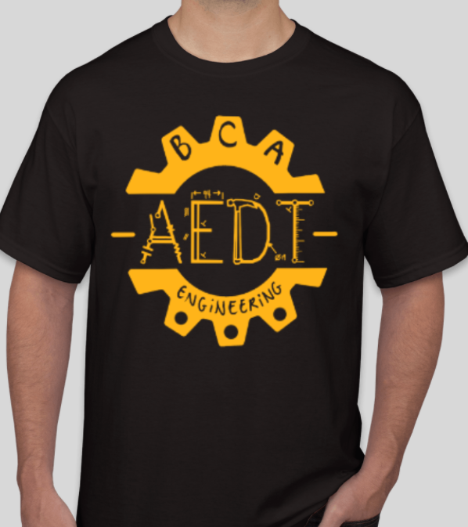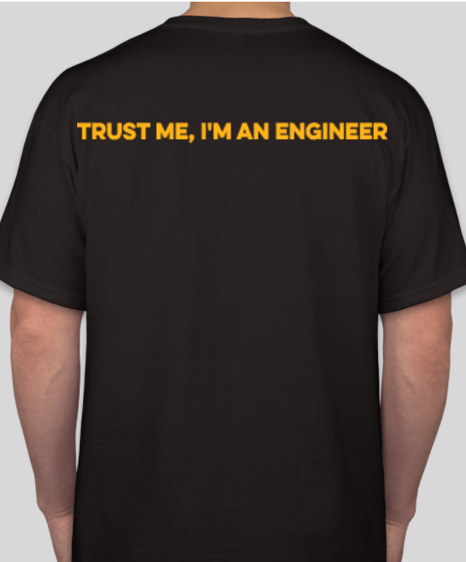

NAME (student)__________________ GRADE ____ IGS____________

Please indicate quantity of each size
S_______ M_______ L _______ XL_______

Please mail this order form with a check payable to Academy PPO/E-PA to:
Tal Millet, 626 White Pine Rd., Franklin Lakes, NJ 07417

