Show your pride in your BCA GRAD!!!
Purchase a BCA Graduation Sign!
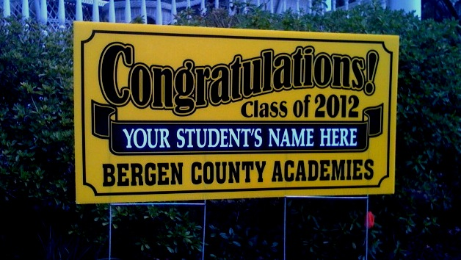
Get a customized sign for your Class of 2014 graduate!!!!
These beautiful 100% all weather signs are 24” X 48” (larger than pictured) and come with metal stakes for lawn installation or they can be hung in your window.
Custom printed for BCA in Black & Gold, they are $30/sign.
A perfect way to welcome everyone to your graduation party!
All orders must be received by May 1, 2014. Signs will be delivered to BCA in early June. To place an order, please complete and return:
Name: ______________________________________________________________
Email: ______________________________________________________________
Graduates name as you want it to appear on sign (please print):
_____________________________________________________________________
Number of signs: ____ Total ($30/sign): _____ Checks payable to BCA Student Activity Fund Class of 2015.
Mail orders to: Lisa Caron, 145 West Ridgewood Ave., Ridgewood, NJ 07450. Questions? Please contact us at Lisa.caron3@verizon.net
(A minimum of 100 signs need to be ordered for our order to be placed.)

