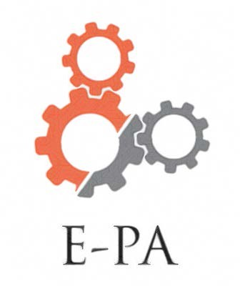

Engineering Parent Group
Join the parent group of AEDT students!
E-PA activity plans include:
- Presentations by engineering and design professionals
- AEDT student panels
- Engineering lab tours
- AEDT senior awards (awarded to members only)
- Engineering field trips
- Networking opportunities with engineering organizations
- Social and fundraising events for students and families
- Supporting engineering competitions, clubs, and activities

Membership is open to all BCA families who are interested in engineering and design.

E-PA Membership Form for the 2018-2019 school year is attached. Please remember that your annual membership fee of only $20 truly helps support our AEDT students!

Questions? Suggestions?
Please contact Tal Millet
talmillet@hotmail.com 201-774-1877
Please mail this form with a check payable to Academy PPO/E-PA to: Tal Millet, 626 White Pine Rd., Franklin Lakes, NJ 07417
___________________________________________________________________________

E-PA Membership Form for 2018-2019

Please check all that apply.
- YES, we would like to join E-PA. Our $20 dues for the school year are included.
- Please accept our additional donation of $_______ to support E-PA activities.
- I would like to serve as an officer on the E-PA board.
- I work in an engineering or design field.
- I have a professional contact that could help us as a speaker or resource.
- I would like to volunteer at an event.

Please print neatly.
Name of student(s) ___________________________________________________
Academy & graduation year _________________________________________
Name of parent(s) ____________________________________________________
Parent(s) email address ______________________________________________
Phone number _________________________________________________________

